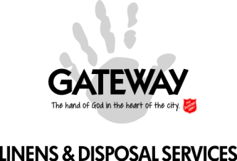
A “Broadview Bulletin” Newsletter

Gateway Linens & Disposal Services (GL&DS) is an enterprise serving as an employment retraining program of The Salvation Army. We are so appreciative of our “customers,” who we genuinely refer to as our partners, without whom this program would not exist. One of our key commitments is to do our best to communicate with you quarterly via this “Broadview Bulletin” newsletter, to provide a glimpse into what is happening because what we do, and our relationship with you, is about far more than cleaning your linens or disposing of your garbage. We also exist to partner with you in being a transforming influence in people’s lives and contributing to a better, more socially aware, compassionate and connected community.

September 2016

CHANGE OF SEASONS

On September 22nd this part of the world officially changed seasons, from summer to autumn. At this point the changes are subtle… darkness arrives a little earlier in the evening, nights are cooler, the leaves on some trees are slowly changing their colours. For many people, autumn is their favourite time of year.

This change of seasons serves as a metaphor for what we do… what all of you, our partners, our readers, do… which is to help affect positive change in the lives of people who may be marginalized, who may be in a dark place, who may need a guiding hand toward a brighter future. At Gateway Linens & Disposal Services, we are an industrial laundry operation and a garbage disposal service (check), and we serve as an employment retraining program (check), yet ultimately we simply see ourselves as an entity created by The Salvation Army to help be a transforming influence in our community. Partners, readers, we hope that this season of vibrant colours and cooler temperatures will, for all of us, represent a season of greater hope for those we serve.

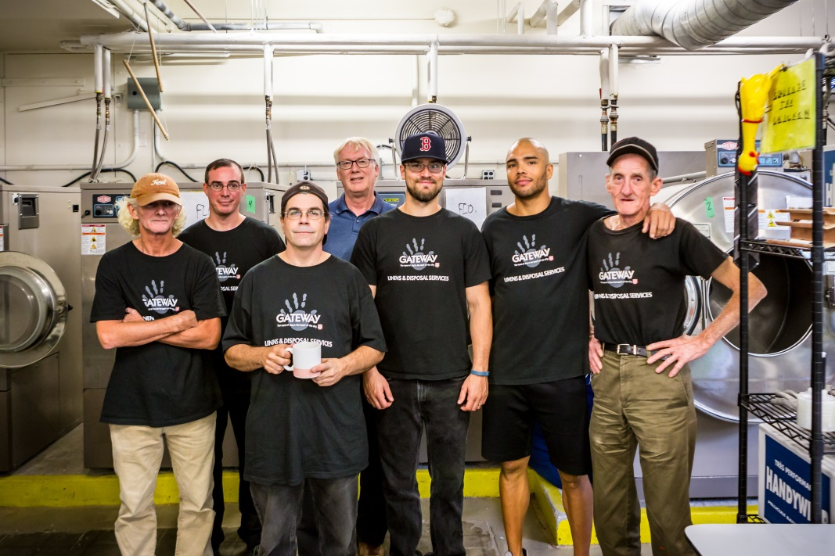

NEWS & NOTES

We have entered into an exciting partnership with the City-funded Toronto Hostels Training Centre to host monthly workshops at GL&DS. These workshops are a mandatory part of case management for our program participants, and are also open, free of charge, to the residents and clients of our partners. To date, highly successful workshops have been conducted in Communication Skills, Resume Skills, Working with Difficult People and, most recently, a full-day First Aid & CPR three-year certification training. Upcoming scheduled workshops, with some spaces still available, are:
- October 21 – Stress Management
- November 25 – Interview Skills
- January 20, 2017 – Communication Skills

The “view” from our property at 312 Broadview Avenue has dramatically changed. As a part of a seven-mural project undertaken by the Chinatown East Business Improvement Association in partnership with the City of Toronto and the Toronto Police Services, the entire wall of the next-door building that abuts our parking lot has been transformed into a stylized version of the Great Wall of China… a colourful and dynamic addition to our neighbourhood. The photo to the left was taken during the late stages of the mural’s creation.

If you know us at GL&DS, or have read our previous Broadview Bulletin newsletter, you will know that we love to CELEBRATE!! We frequently experience great celebration-worthy opportunities, with significant milestones reached by our program participants, and others who move on to a more positive, independent future within the community. There are other times when we celebrate simply because we feel like celebrating!!... the end of summer!... LIFE!! In recent months we have held periodic lunch-time community-building barbeques on our property, for all associated with our program, and we also enjoyed a celebration dinner at Nando’s restaurant, which has become the go-to favourite for our program participants!

There has been a lot happening…  - New opportunities, including an interesting special disposal job contracted with Crosslinx for the Eglinton LRT transit project  - Gateway shelter/GL&DS staff retreat  - Organizational assessment and improvements  And lots more to come, including…  - Annual linens inventory with all of our partners | 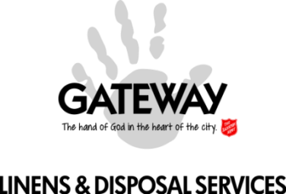

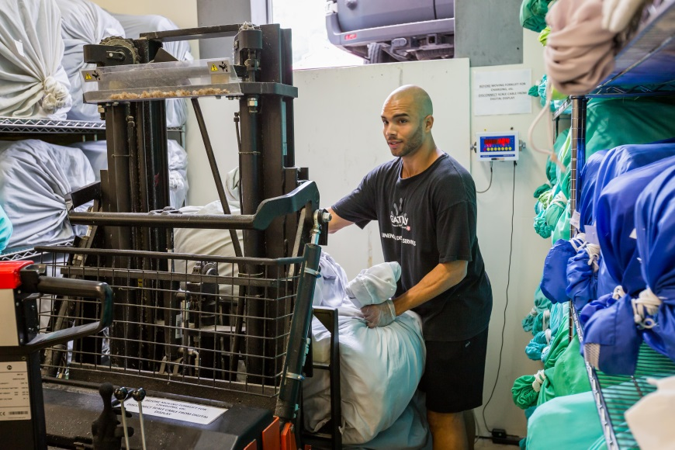

PROGRAM PARTICIPATION UPDATE

We have experienced almost unprecedented “stability” over recent months, with very little turnover in our participant team. This is actually a “good news, bad news” scenario. The “good” is that very few participants have left the program and our current group has made excellent progress in their structured case management and goals achievement. The “bad” is that, due to limited capacity in our present program, “stability” means that limited turnover also results in limited opportunities for those on our waiting list. Our objectives for business growth - to bring on new service partners - are specifically targeted so that we can expand the number of participants who can access GL&DS.

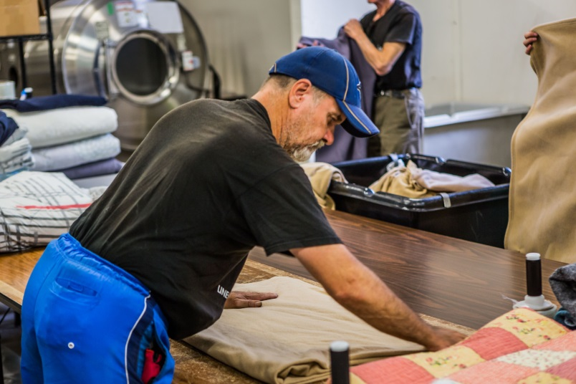
The path to “success” is rarely a smoothly paved straight line, and this may be especially evident with those who go through our program. Confidentiality prevents us from sharing many of our “impact” stories. In the past month one of our participants (Note: not the person pictured in the photo above) experienced a serious bump in his road, having to face the ongoing challenges present in addictions recovery. He not only came through it but gained positive new insight and strength, and he has returned to a good path within our program. Equally worthy of celebration was how our other program participants and the entire GL&DS team rallied around to create a thoroughly supportive, encouraging environment.
Please check out this link to a “Participants’ Snapshot” - https://www.youtube.com/watch?v=rW4bPIax8-0

